Public CMS V2021

Secondary development manual
目录
One. Introduction to Public CMS 1
1. Profile 1
2. Lisence Agreement 1
3. Access to Public CMS 1
4. Directories 2
Two. Development Tools 2
1. Import Maven Project 2
2. Import General Project 6
3. Development Tools Configuration 9
4. Project configuration 14
5. Project debugging 14
6. Publish Project 20
7. Run the project 23
Three. Secondary Development 23
1. Intruduction to the project 23
2. Hibernate entity auto generation 25
3. Atomatic generation of Logical code and page 33
4. Mybatis codes auto generation 36
Four. Support service 37
1. Free service 37

Introduction to Public CMS

Profile
The Public CMS is designed based on the latest 2021 Java technology with open source code and frindly structure to SEO. Public CMS can operate/manage hundreds of thousands data and PV easily. Public CMS has been accepted and used by many famous companies and enterprises, and it owns a total of 0.0002% of the total websites of the world. We provide free version and technology support , and we believe Public CMS will be a good choice for great data website construction and big enterprise projects.
- Public CMS is suitable for both dynamic website and static website;
- Public CMS can support multi-site creation, with totally separate data and template for each website.

Lisence Agreement
1. License
1.1 This version of the software is licensed under the MIT License (http://www.opensource.org/licenses/mit-license.php)
1.2 Licensee has the right to use, copy, modify, merge, publish, distribute, sublicense and sell the Software and the source code of the Software.
1.3 The Licensee may modify the terms of the license to the appropriate content according to the needs of the program.
1.4 Copyright and permission notices must be included in the Software and all copies of the Software.
1.5 Your redistribution may be advertised under the name PublicCMS.
1.6 Third-party products that contain other licensing agreements in the Software shall comply with their licensing agreements.
2. Copyright
2.1 The copyright of this software belongs to PublicCMS
3. Disclaimer
3.1 The Software and accompanying documentation are provided without any express or implied compensation or warranty
3.2 If the user uses the software voluntarily, you must understand the risks of using the software, and we do not promise to provide any form of technical support and guarantee for the use of the software before purchasing the technical services of the product, nor do we assume any responsibility for the problems caused by the use of the software

Access to Public CMS
Public CMS source code:
GITEE: https://gitee.com/sanluan/PublicCMS
GITHUB: https://github.com/sanluan/PublicCMS

Directories
data/publiccms
publiccms-parent

- data/publiccms` s sub- directories:
Indexes: Full-text search engine, automaticly created by the system;
Task: Script for task plan
Template: Directories for templates
Web: Directories for static website and resource documents
- publiccms is an excecutable program, whose codes can be operated by J2EE website container or java –jar publiccms.war.

Development Tools
After importing Public CMS in Development Tools, you can Compile and modify its source codes freely and do further development.
Download address https://www.eclipse.org/downloads/

Import Maven Project

Steps
- First, choose “Import” under the File menu
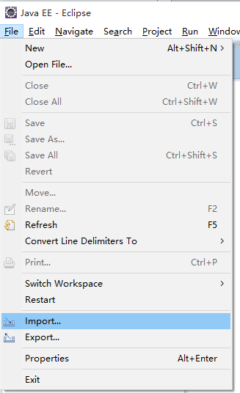
- Choose “Maven->Existing Maven Projects” in the pull-down menu ( import exsisting Maven Project)
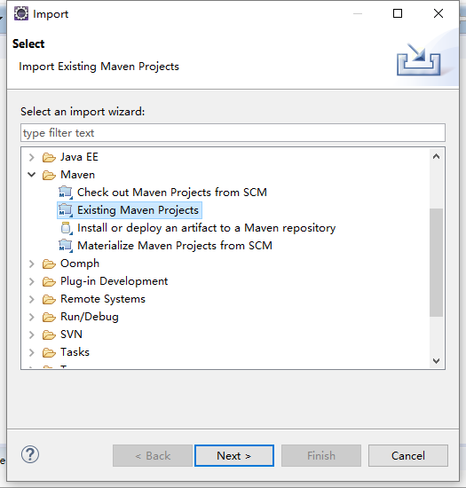
- Choose ”publiccms-parent” under the pull-down menu of root directory
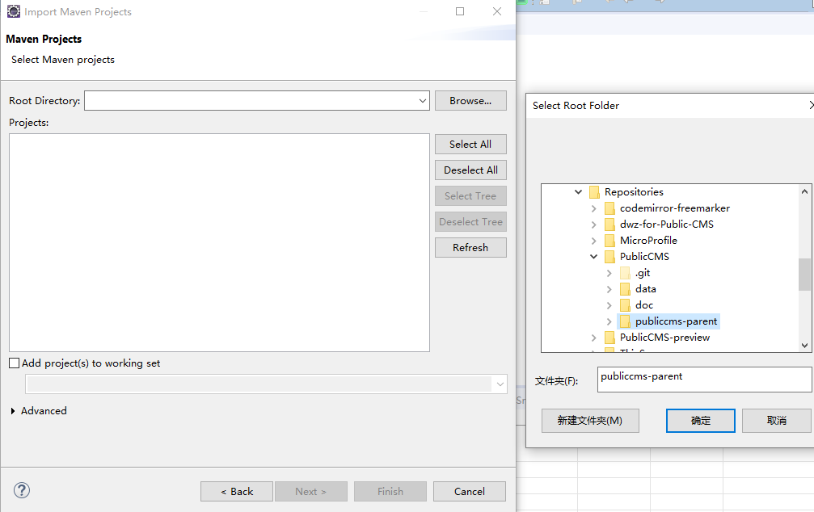
- Click “ finish” to complete the import.
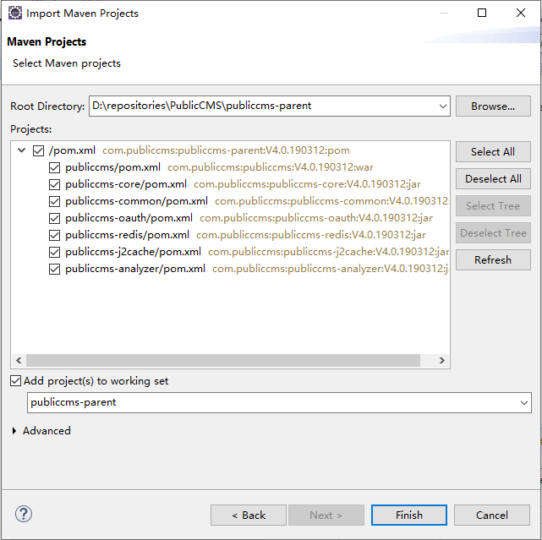

Import General Project

Steps
- Execute the command of “mvn eclipse:eclipse” or “gradle eclipse” to Generate the eclipse configuration.
- First choose the “Import” under the file menu
- Choose “General->Existing Projects into Workspace” in the pull-down menu ( import the existing Project)

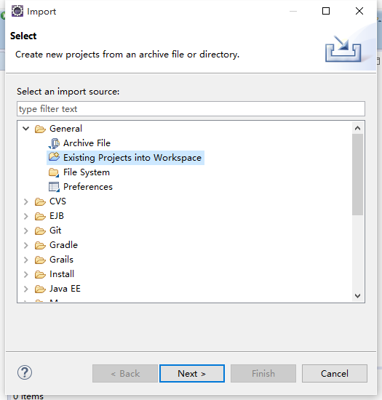
- Choose ”publiccms-parent” under the pull-down menu of “Select root directory”.
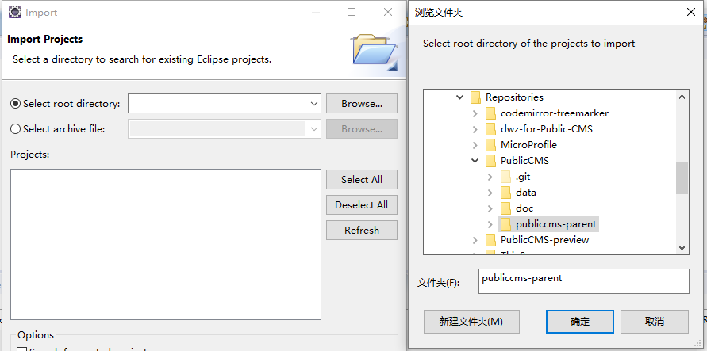
- Tick the “Search for nested projects” and click “ Finish” to complete the import.
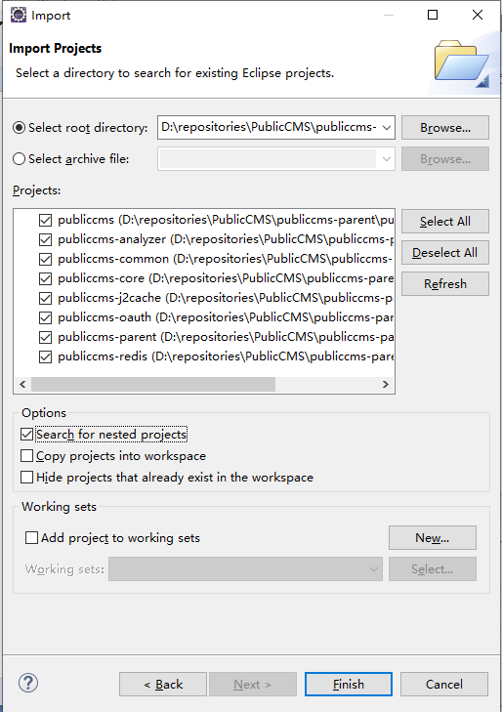

Development Tools Configuration
Development Tools Configuration is to make it easier for you to develop Public CMS, and keep the codes style alike.

Import formative files (optional)
Choose ”Preferences” under the window menu
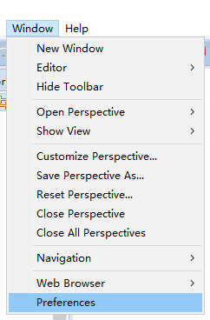
Follw the route of “Java->Code Style->Formatte” ,and click “Import”
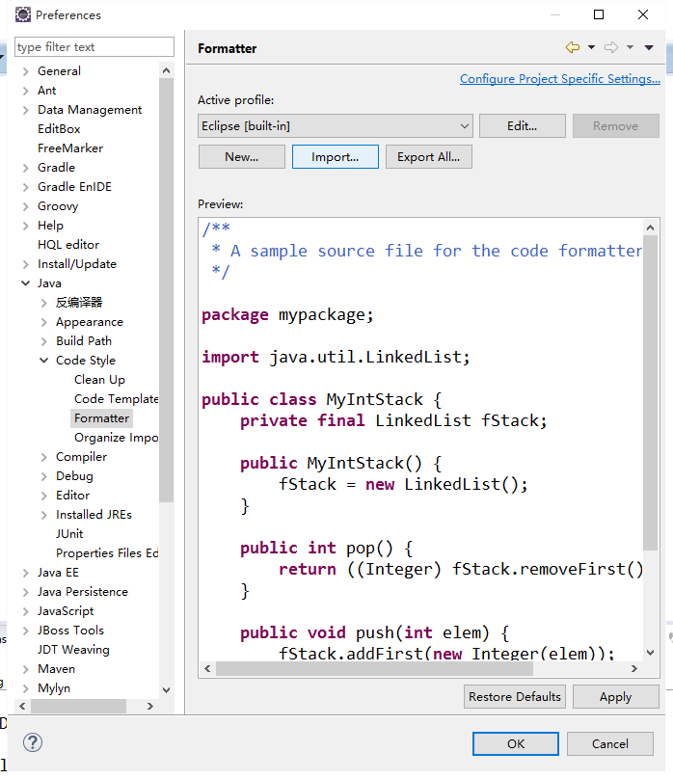
choose java.xml file
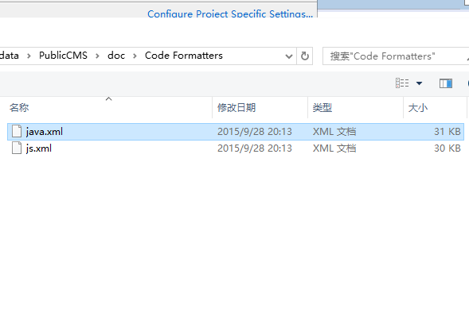
import “js.xml” into “JavaScript->Code Style->Formatter” in similar way

Character encoding configuration
encoding of the project is in UTF-8 format
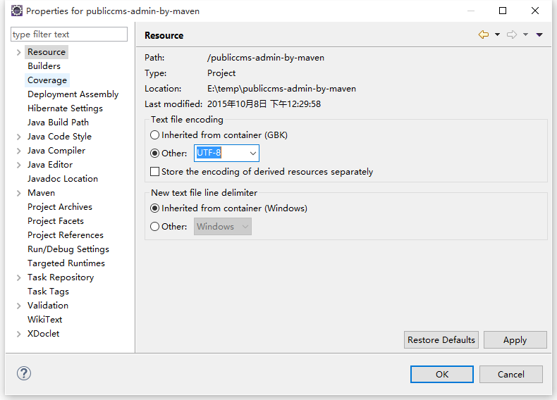

Verification configuration
Eclipse verification code can’t realize the error of “html&freemarker”, and give false error report,so cancle the tick of the following Validator to better find the rael error.
Client-side JavaScript
HTML Syntax Validator
JavaScript Validation
JSP Content Validator
XML Validator
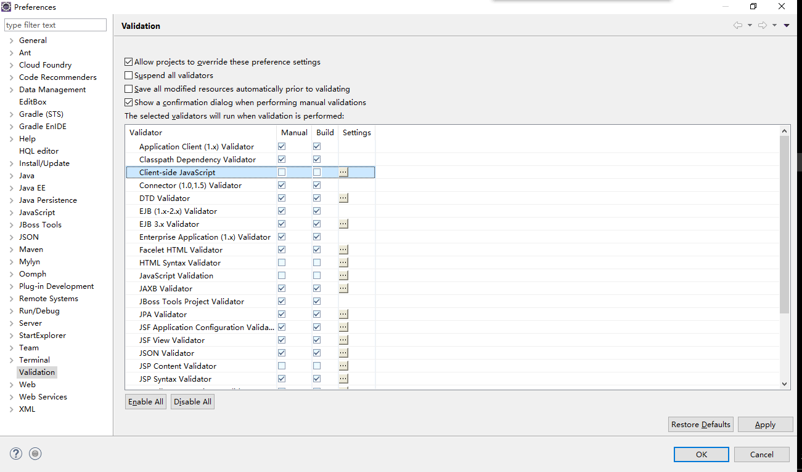

Development tools plug-in (optional)
The Eclipse plug-in of FreeMarker editor is in the jboss tools.
http://download.jboss.org/jbosstools/updates/stable/ (choose the IDE version )
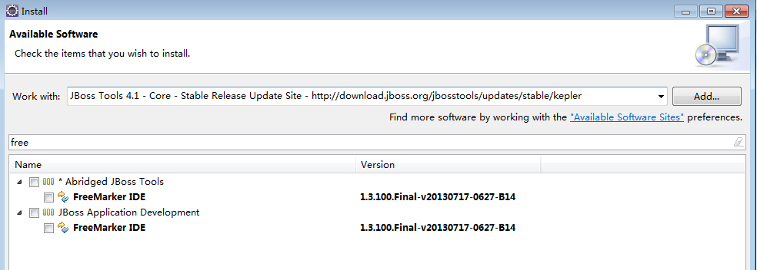
Search for FreeMarker IDE and install it.
Tips: FreeMarker IDE updates slow and is not very stable. It can not speed the development for technists familiar with FreeMarker, so only beginners of FreeMarker are advised to use it.

Project configuration
Project configuration files are under the “src/main/resources” menu.
cms.properties are CMS configuration file.

Configurations | Discription | Remarks
cms.filePath | Absolute path for CMS data directory
cms.masterSiteIds | Mmanagement website ID | different ID should be separated by a half-angle comma
cms.defaultSiteId | Default website ID
cms.tokenizerFactory | Default Tokenizer : hmmchinese | keyword,letter,lowercase, whitespace,edgengram, ngram, pathhierarchy, pattern, classic,standard, ax29urlemail, thai, wikipedia, hmmchinese
cms.task.threadCount | Task scheduling thread count
cms.multipart.maxUploadSize | Maxmium for uploaded files
The cms.filePath in Configurations column can be configure by -Dcms.filePath parameter.
If there are no install.lock under the data directory or the configuration is wrong, the installment interface will be popped-up by default after visiting the program. Fill the information of the database, and choose to initialize or update data base. You can also initialize or update data base manually later.
The initialization script of the data base is under the “WEB-INF/classes/initialization/sql/” directory; data base updating script is under the “WEB-INF/classes/initialization/upgrade/” directory;

Project debugging

Traditional Debugging
Development tools debugging can be done through Unit testing by editing encoding or through online debugging when running the project in web container. Online testing is better choice for Template debugging.
Choose Preferences under the Window pull-down menu, and follow the route “Server->Runtime Environments”, and add a container newer than Tomcat7.0.57.
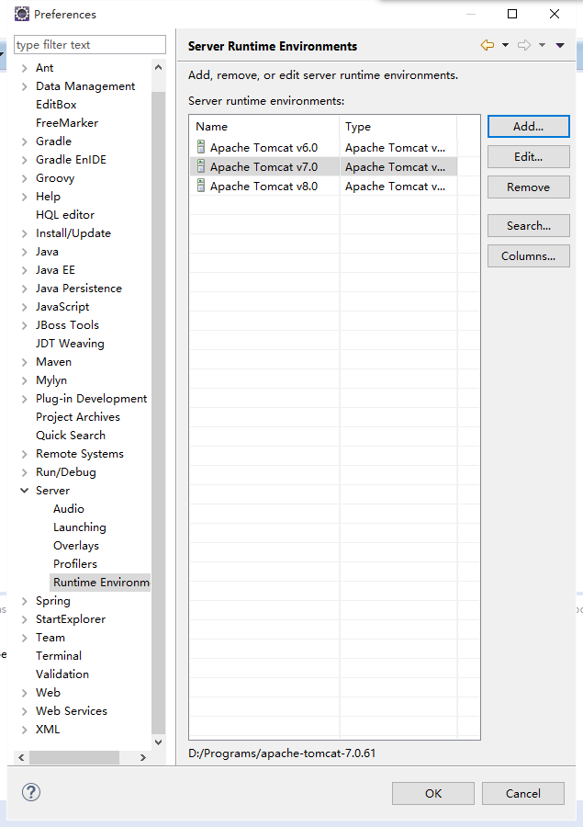
Click on the right ,choose “Debug on Server” under the “Debug As”, or choose “Run on Server” under the “Run As”.

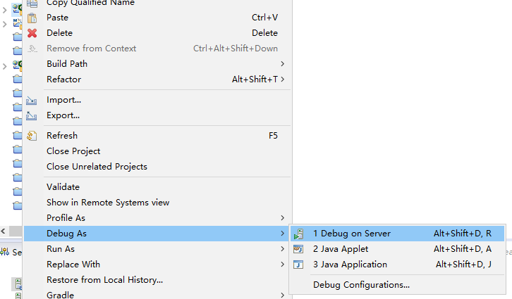
Choose the newly added container, and click “Finish” to complete.
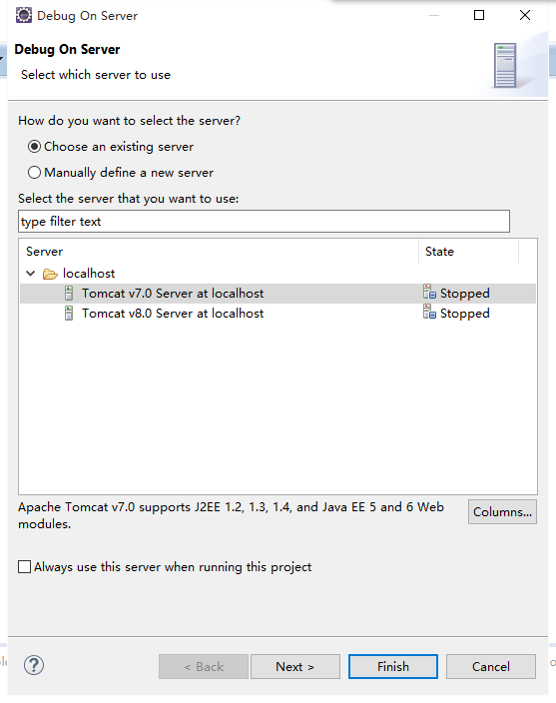
Now you can debugging or running the project.
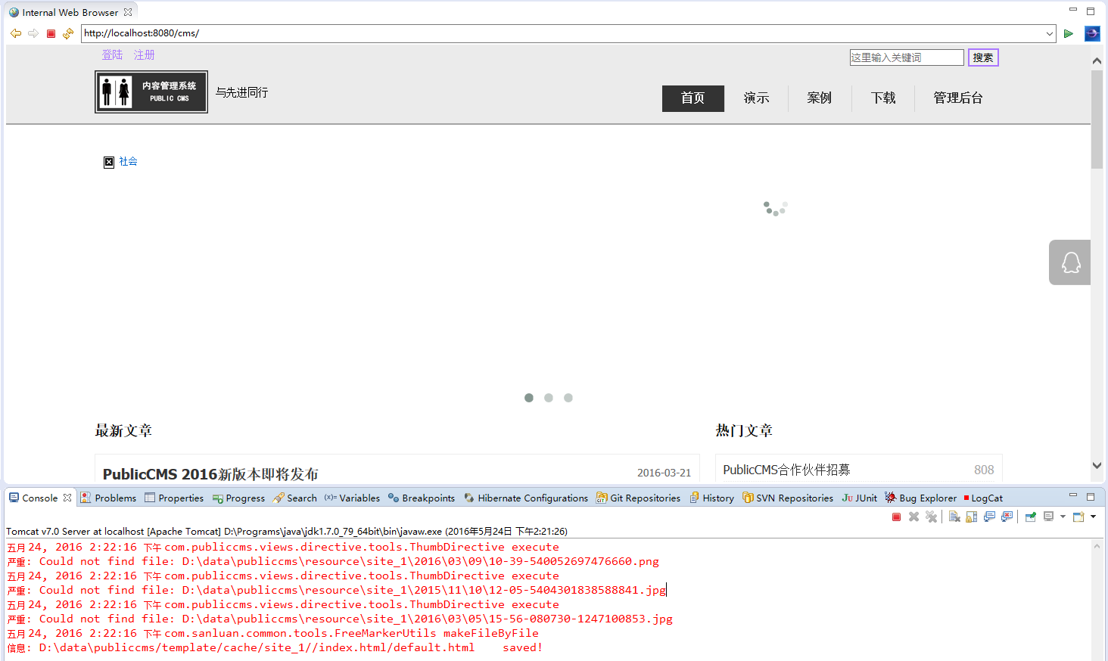
You can also find the “Show View” sub menu of Window, and choose “Other”.
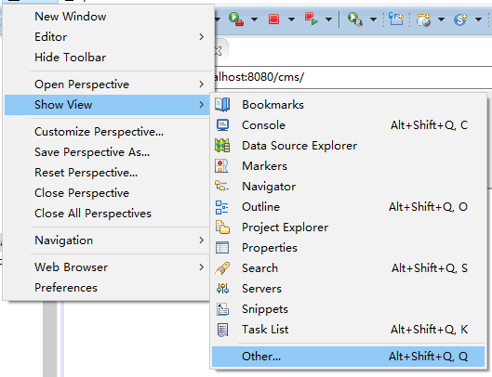
Click “Servers”
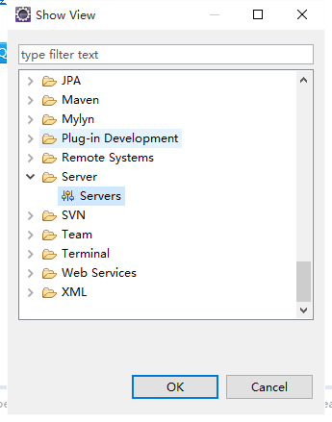
Manage the container and the projects running or debugged in it.
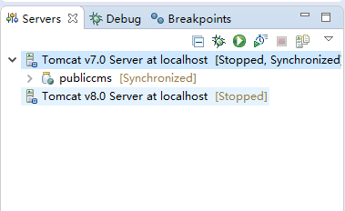

SpringBoot format debugging
Find ”boot.SprintBootApplication” in PublicCMS project, choose “debug” or “run” according to your needs and execute “Main” method.

Publish Project

Publish the script
Execute the “mvn package” or “gradle war” order, generate the file “publiccms-parent/publiccms/target/ publiccms.war”

Publish eclipse project
- Choose publiccms project, click on the right , then choose "Export", and choose "War file" on the sub menu.
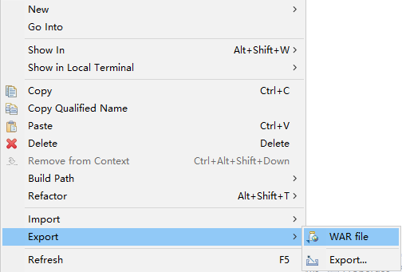
- Save war package and click “Finish” to complete.
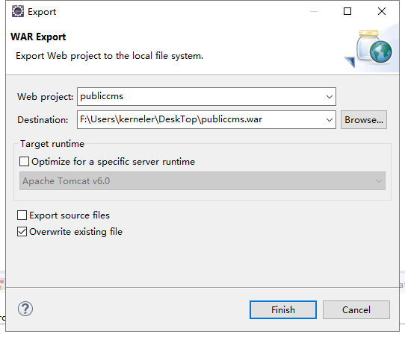

Publish eclipse maven project
- Choose “publiccms-parent” project,click on the right ,and choose "Run As" in the pop-up window，then choose "Maven install" in the sub menu.

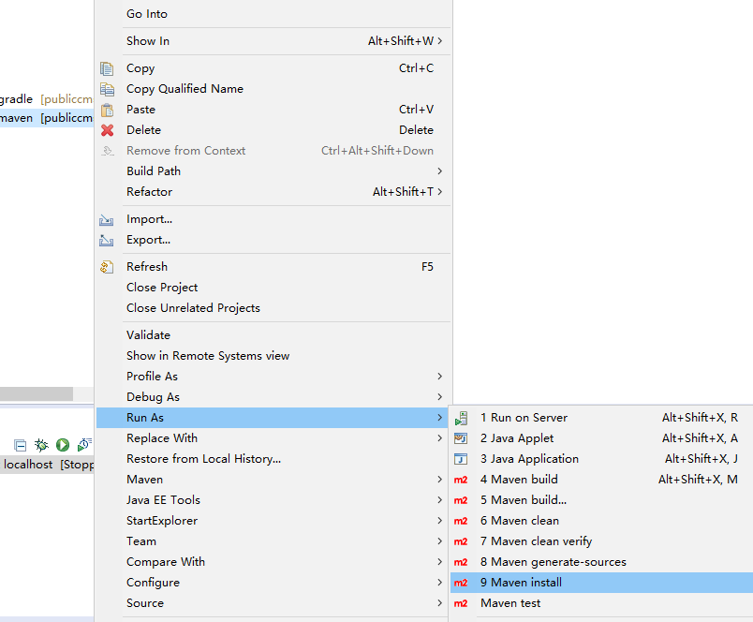
- If compiled successfully, you can find the “war package “under the “target” directory of publiccms.
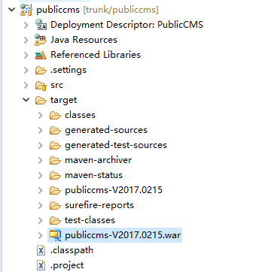

Publish eclipse gradle project
- Choose publiccms-parent project, click on the right, and choose "Run As", then choose "Gradle build.." on the sub menu.
- Tyoe in war
- Find war file under the build directory

Run the project

Traditional way to run the project
Put “war” under the ”webapps” directory of tomcat or the corresponding directory of other containers.

SpringBoot way to run the project
Execute the command of “java -jar publiccms.war”

Secondary Development

Intruduction to the project

UI framework design of Management Interface
Management UI interface uses dwz UI framework, the whole Management interface is united in one page. All the workspace tab content are obtained through ajax request, and then be appended to the management pages in html Fragments form. Initiate the “js effect” of the appended pages. Compared with json, the above methed can present the pages in a easier way.

Project Design
Public CMS use the following softwares and their packages: SpringMVC, Spring Boot, Hibernate, Hibernate Search,Mybatis, FreeMarker, Mysql jdbc, c3p0, jedis, jackson, quartz, Apache commons. Package dependency and Compile engineering are handled by Maven,gradle.

Soft request are executed by several Servlet: management Servlet，front Servlet，interface Servlet，static file Servlet，install Servlet。

Management Servlet，front Servlet，interface Servlet are executed by DispatcherServlet of SpringMVC. IndexAdminController, IndexController maps the default request, so they have the lowest priority. The order of dealing the request is appending the page templete of the request route. The appending process of pages uses FreeMarker command to extend the obtain of the data and reduce the frequency to modify the management interface. The JAVA ecode can repeated to the most in the view layer. Excel are received and processed by the traditional SpringMVC Controller

Naming conventions and project structures
Java Code：
.common tools and Resolver package
.base fudmental package
.datasource data source package
.directive directive base package
.cache cache package
.constants Constants define packages
.handler Paging processing, query processing, FreeMarker exception and other processor packages
.generator code generation tool package
.search Full-text search component package
.servlet Servlet package
.tools tools package
.view view layer base package
.entities Entity package
.logic logic package
.component component package
.dao Database operation package
.service Transaction and logical encapsulation package
.controller controller package
.web front website controller package
.admin management interface controller package
.api interface controller package
.views view package
.directive freemaker user-defined directive package-freemaker
.method freemaker user-defined method package
.pojo Form entity package
.boot SpringBoot entrance package
config.spring Spring configuration package
config.initializer Servlet loader

resource files
resources
config configuration file
language language file
templates template file
admin management template file
ftl auto-loaded freemarker template
web front page templete (Lower priority to template in the data directory)
cms.properties cms configuration files
log4j2.properties dairy configuration files
webapp error http error page( only effective when deployed in traditional web container)
META-INF java application description files
resource management interface static resource files
WEB-INF java applicationSecurity directory
index.html prompt page for incomplete project

Hibernate entity auto generation

Generated through the project code
- Database configuration(modify the database information of configuration file: publiccms\src\test\resources\hibernate\hibernate.properties)
- com.publiccms.common.generator. EntitysGenerator
- Refresh to see the newly generated code

Generated through components of development tools
- Install “Hibernate tools”, choose “Eclipse Marketplace…”under the Help menu

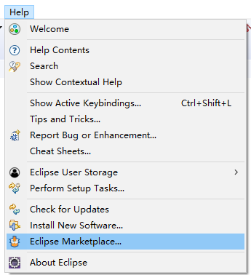
Search the app market for jboss tools
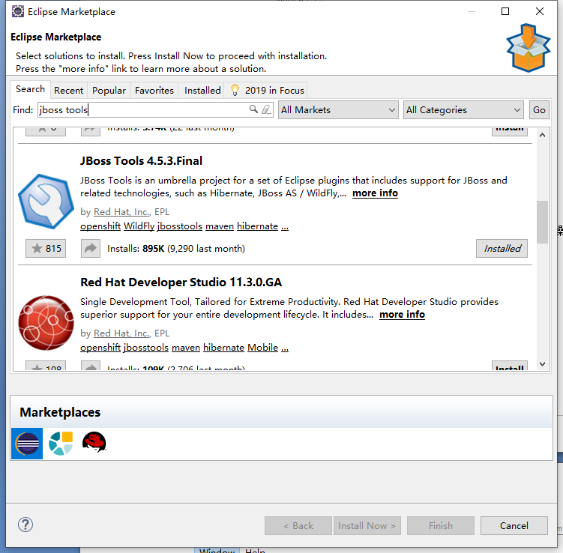
Tick hibernate tools ,click finish
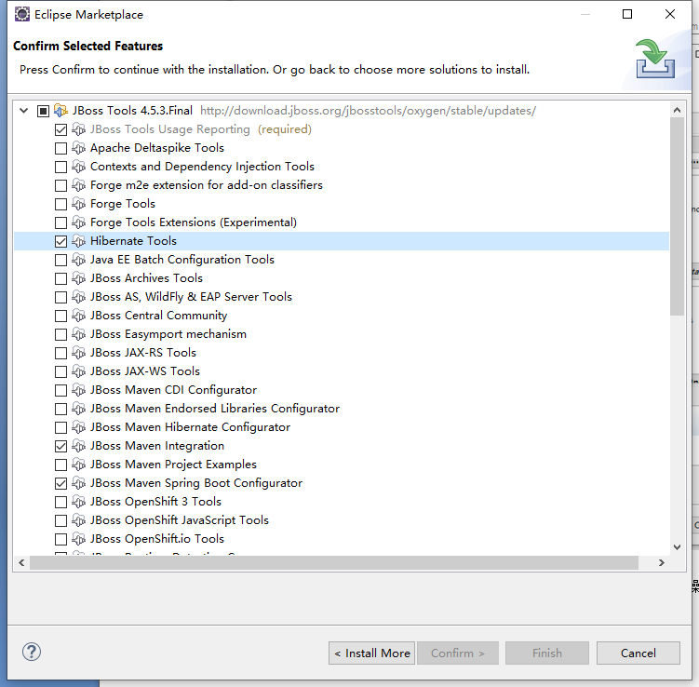
- Use hibernate tool to generate entity, modify data base configuration files
Open the “Hibernate Configuration” view in your development tools
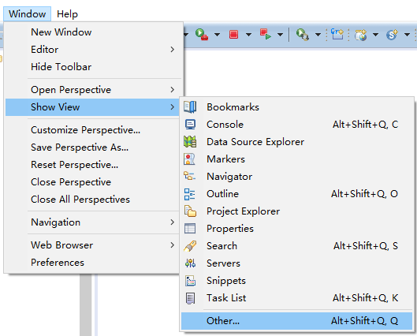
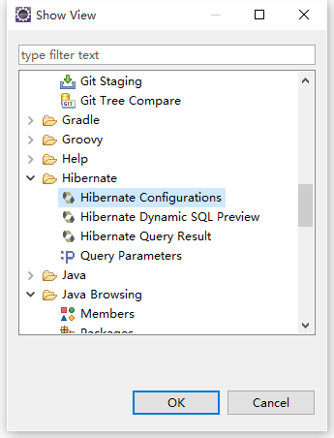
Add Hibernate configuration

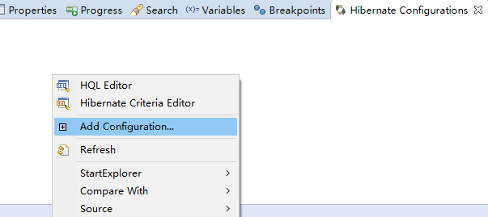
选择Annotations注解类型的实体，新建或者选择已有的数据库，选择publiccms/src/test/resources/hibernate目录下的properties和cfg.xml文件或者自己新建这两个文件，点击ok保存
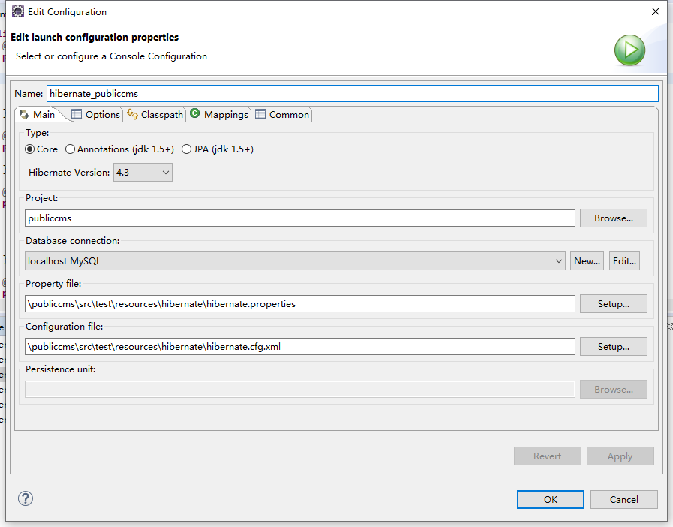
Open “Customize Perspective...” view
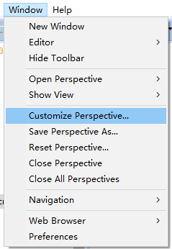
Switch to the Command Groups Availability tab, find Hibernate Code Generation directive and tick it.
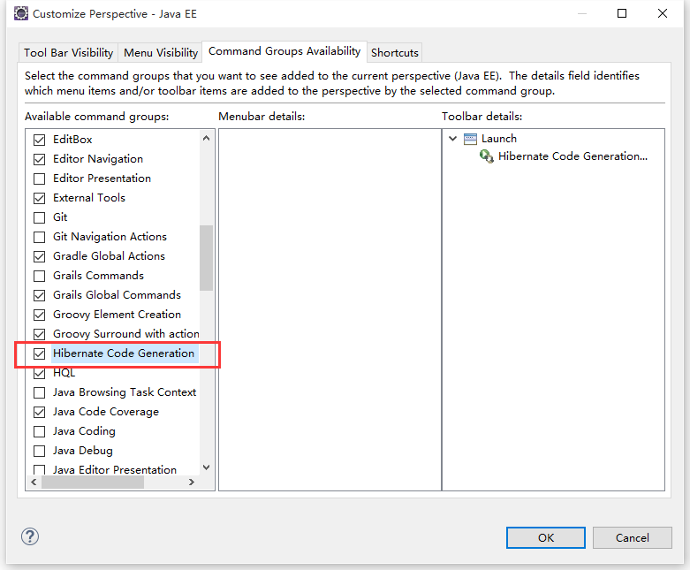
Find the Hibernate code generation tool in eclipse toolbar. Click Hibernate Code Generation Configurations.
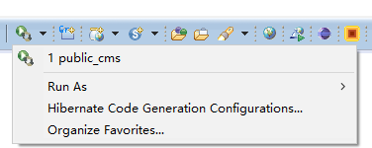
Choose hibernate.reveng.xml file under the “publiccms/src/test/resources/hibernate “directory, or create a new file by yourself.
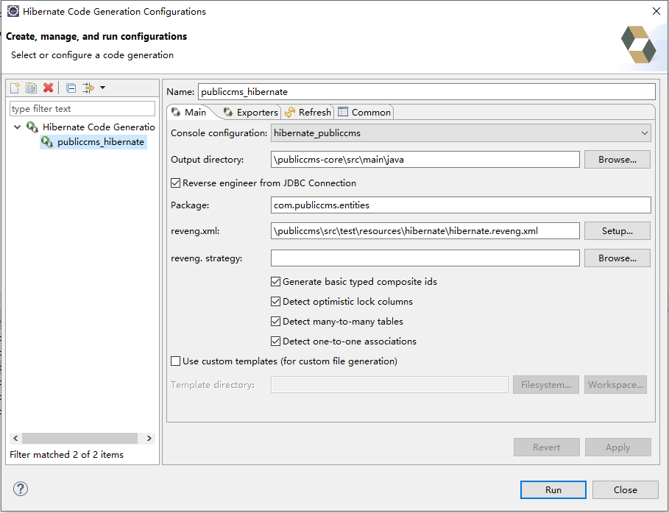
Switch to Exporters tab, check Generate EJB3 annotations and Domain code(.java)
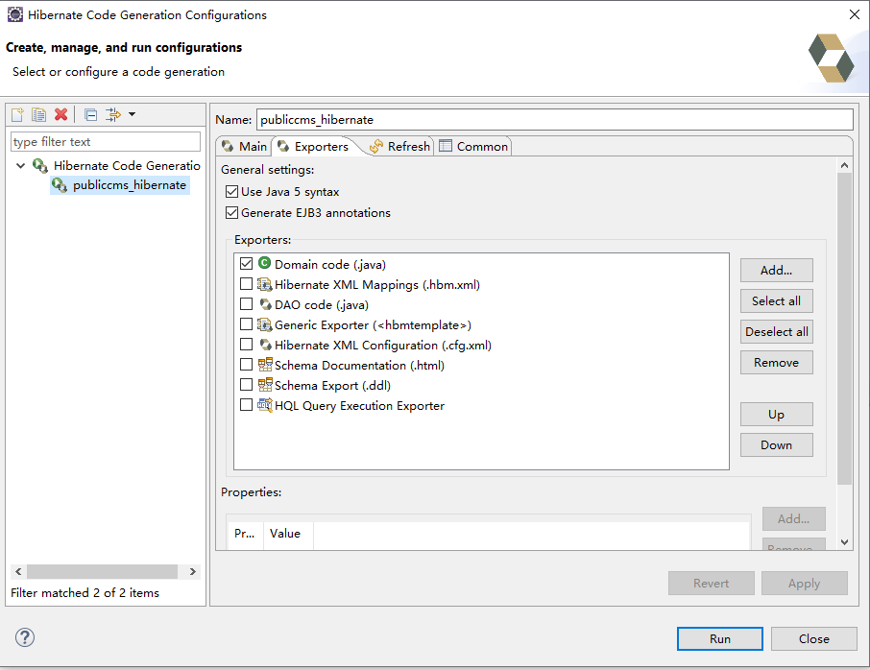
Then click run to generate entity with notes

Atomatic generation of Logical code and page
This generation method will automatically generate self-definition directive、Controller、Service、Dao、html, according to the annotation, after marking the hibernate entity, and is the main generation method during the developing period of CMS.

  - For entity property, use annotation to tag the field type【condition: whether used to search conditions，order: whether used to rank ，like: search conditions are similar to，or: search conditions are” or logic”，name: field name，when or is true，fields with same name share the same or conditons,，title: real meaning of the Field】
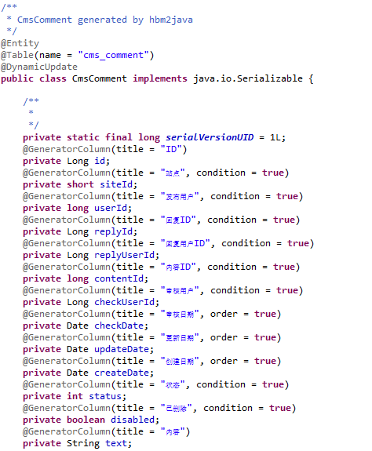
  - Generate code file using : com.publiccms.common.generator.SourceGenerator”
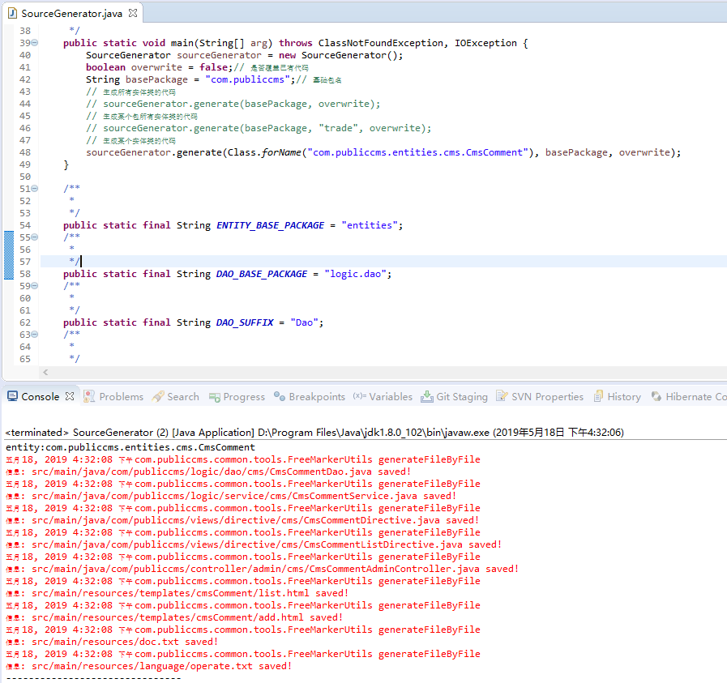
  - Refresh the project to see the newly generated codes

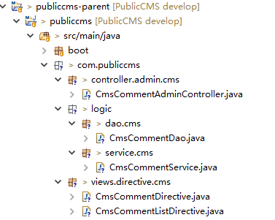
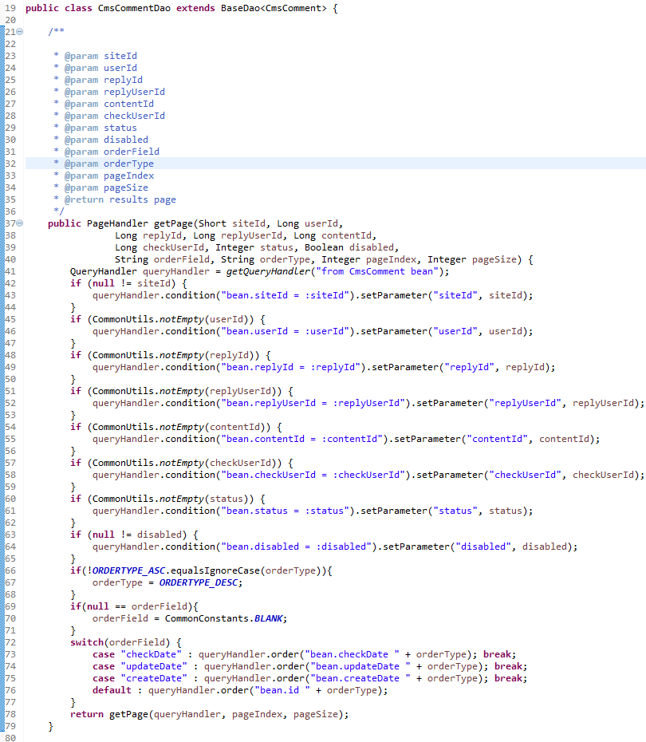

Mybatis codes auto generation
  - Modify the relative data base property of “src/test/resources/generator/mybatis/generatorConfig.xml” to make sure the data base is correct and Can be connected；
  - open the file: src/test/java/com/publiccms/common/generator/MybatisGenerator.java
  - operate main function to generate Mybatis code file
  - 4refresh the project to see the newly generated code

Support service

Free service
Public CMS Official website:https://www.publiccms.com/
QQ Group:191381542 , 481589563 , 638756883
Freemarker Manual :http://www.kerneler.com/freemarker2.3.23/
Debug FreeMarker online：https://www.sanluan.com/freemarker_test.html

